**RAILWAY MANAGEMENT SYSTEM**

**ENDTERM REPORT**

*By*

Vishal Das: RK17EBB47

Mirthipati Kesava Rao: RK17EBB34

Gundeti Chinnesh: RK17EBB38

Kishor Mitra: RK17EBB48



Department of Intelligent Systems

School of Computer Science Engineering

Lovely Professional University, Jalandhar.

20-04-2018.

**Student Declaration**

This is to declare that this report has been written by us. No part of the report is copied from other sources. All information included from other sources have been duly acknowledged. We aver that if any part of the report is found to be copied, I/we are shall take full responsibility for it.

Vishal das

Roll No:47

Kishor Mitra

Roll No:48

Mirthipati Kesava Rao

Roll No:34

Gundeti Chinnesh

Roll No:38

Place: Lovely Professional University, Jalandhar

Date: 20/04/2018

**TABLE OF CONTENTS**

|  |  |  |
| --- | --- | --- |
| **Sl. No.** | **TITLE** | **Page No.** |
| 1. | Background and objectives of project assigned | 1 |
| 1.1. | Background and objective | 1 |
| 1.2 | Analysis | 1 |
| 1.3. | Outcome of project | 2 |
| 1.4. | Limitations | 2 |
| 2. | Description of Project |  |

**1. BACKGROUND AND OBJECTIVES**

The purpose of this source is to describe the railway reservation system, which provides the train timing details, reservation, billing and cancellation on various types of reservation namely,

Confirm Reservation for confirm Seat.

Reservation against Cancellation.

Waiting list Reservation.

Online Reservation.

**RAILWAY RESERVATION METHOD**

**ONLINE BOOKING:**

 With the help of this people can book their tickets online through internet, sitting in their home by a single click of mouse. Using their credit cards people can easily get their tickets done within minutes. There are certain charges for online booking as well.

**COUNTER BOOKING:**

 This is the oldest method of booking the tickets. The reservation counters are there at railway department from where people can get the tickets to their respective destinations.

Railway passengers frequently need to know about their ticket reservation status, ticket availability on a particular train or for a place, train arrival or departure details, special trains etc. Customer information centers at the railway stations are unable to serve such queries at peak periods. The number of the reservation counters available to the passengers and customers are very less. On most of the reservation systems, there are long queues, so it takes a long time for any individual to book the ticket. As now, there are call centers facilities available to solve the queries of the passengers.

**ANALYSIS:**

In Online Railway Reservation System, for booking the tickets online the intended user has to enter details like username and password. Once the username and passwords are verified then he is allowed to enter the main system wherein he can select the destination, date and no of tickets. For the purchase of the tickets he is asked for payment details (like credit card details etc). The user is also provided with a provision of canceling the reservation where in the entire amount is credited back to his account. The analysis part also comprises of the UML diagrams that boost the program.

**Objective of Project:**

1. The objective of railway reservation system is to give structural design to railway system.

2. The project provides functionality and flexibility to railway system such that one can operate that system easily and efficiently.

3. This project also provides a complete set of solutions for some common and specific are as of work in the railways.

**2. DESCRIPTION OF PROJECT**

**2.1. Work Division:**

The work areas of the project have been divided among a team of two members in our group.

One working on the templating of the website while the other designing the look and feel of

the of entire project as it progresses.

The layout and styling of the website is being dealt by Vishal Das and

Kishor Mitra together. Keshav and Chinnesh are working on improving the UI and UX, tweaking the Javascript. Every one of us is working individually on the project and we regularly merge the project tweaks to progress with the agreed changes.

**2.2. Project structure:**

1. Ticket booking

1.1. Name

1.2. Age

1.3. Gender

1.4. Address

1.5. Postal code

1.6. Compartment type:-Ac/Non Ac

1.7. Berth preference

1.8. Payment method

2. Schedule

2.1. Train schedule

3. Contact us.

3.1. Contact by number.

3.2. Contact by E-mail.

**2.3. Technologies and Frameworks Used:**

Following are the technologies and frameworks being implemented in the project:

1. HTML - The layout structure of the website has been created in HTML.

2. CSS - The entire styling is handled by the CSS.

3. Javascript – To program the fronted logic.

**BONAFIDE CERTIFICATE**

Certified that this project report “RAILWAY RESERVATION SYSTEM” is the bonafide work of Vishal Das, Kishor Mitra, Keshava Mrithapati and Gundetti Chinnesh, who carried out the project work under my supervision.

**4. Description of work**

Our project has the following divisions:-

1. Home.

2. Schedule of train.

3. About us.

4. Contact us.

5. Login.

5.1.1. Book a ticket.

5.1.2. Payment gateway.

1. Home:-

In home, we have provided the information of our website how to use it and benefits of online reservation system.

2. Schedule:-

We have given the schedule of train timings in which the passenger has to travel to places he wish to travel.

3. About us:-

In this module, we have given information about us and our website and our work effort.

4. Contact us:-

In this module, we have given the user to give feedback and suggestions for our website through e-mail or by contacting us through telephone.

5. Login:-

In this module we have to login to get access for Reservation, Payment Gateway, PNR Status, Cancellation of Ticket.

**Work division:-**

Our team has divided the work into four divisions:-

Our members:

1. Vishal Das has developed the module home, contact us, about us, schedule. Including the CSS and Java script.
2. Kesava Rao has developed the login module and sign up module using java script and PNR enquiry for ticket confirmation.
3. Chinnesh has developed the admin module for easier development and modification of project without complexity.
4. Kishor Mitra has developed the reservation of ticket and payment gateway for booking a ticket and cancellation of ticket.

**Over view of our project**

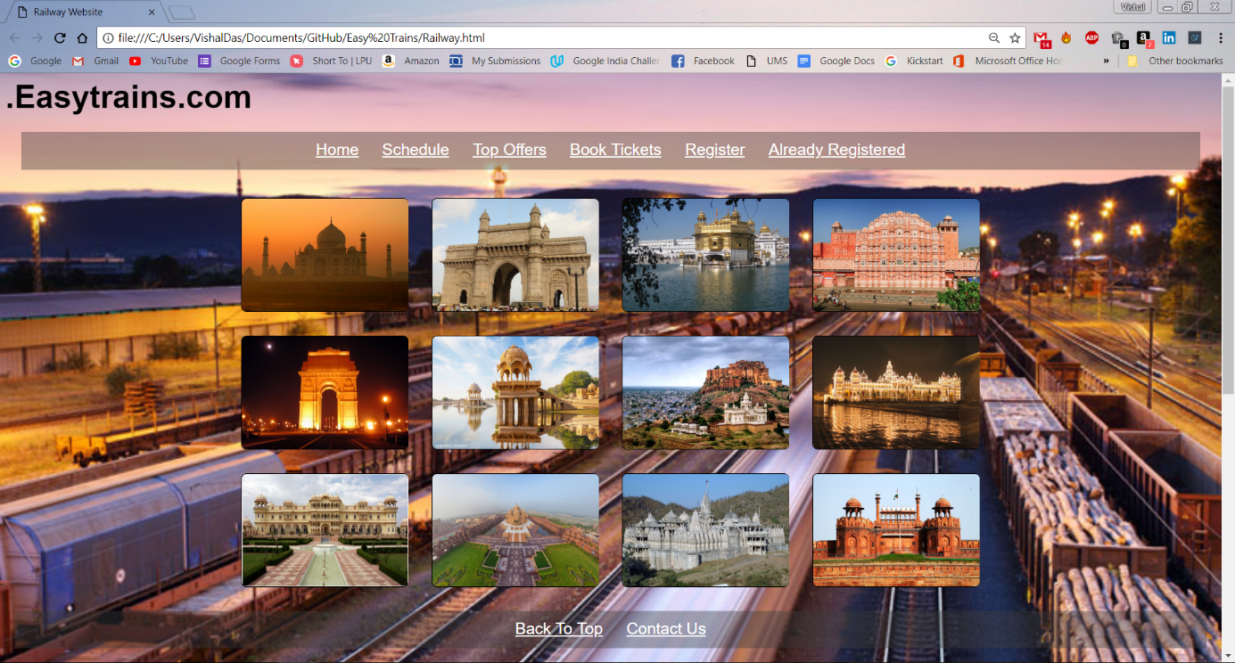

**Home Page**

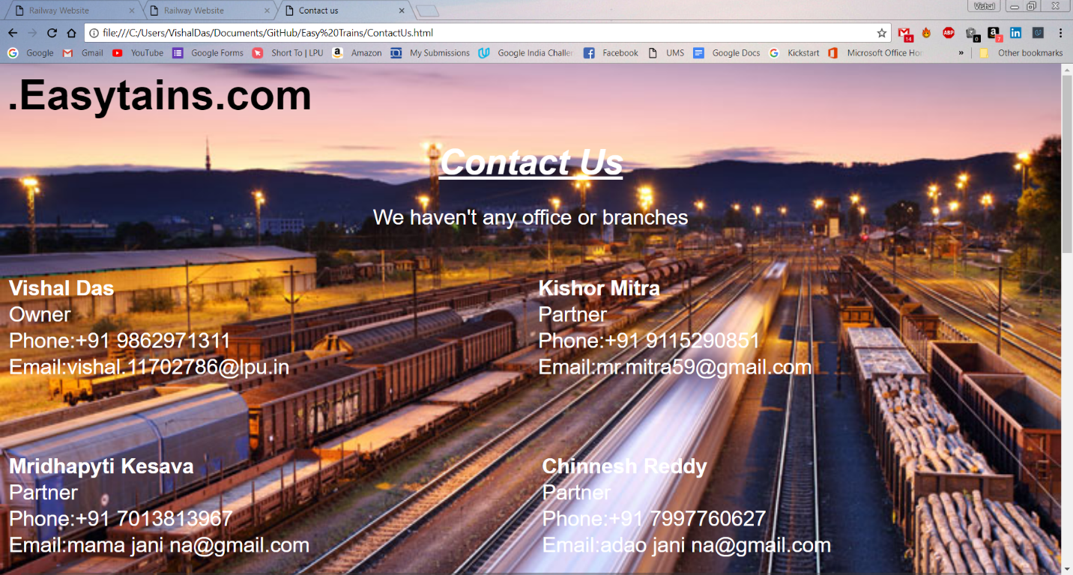

**Contact Us**

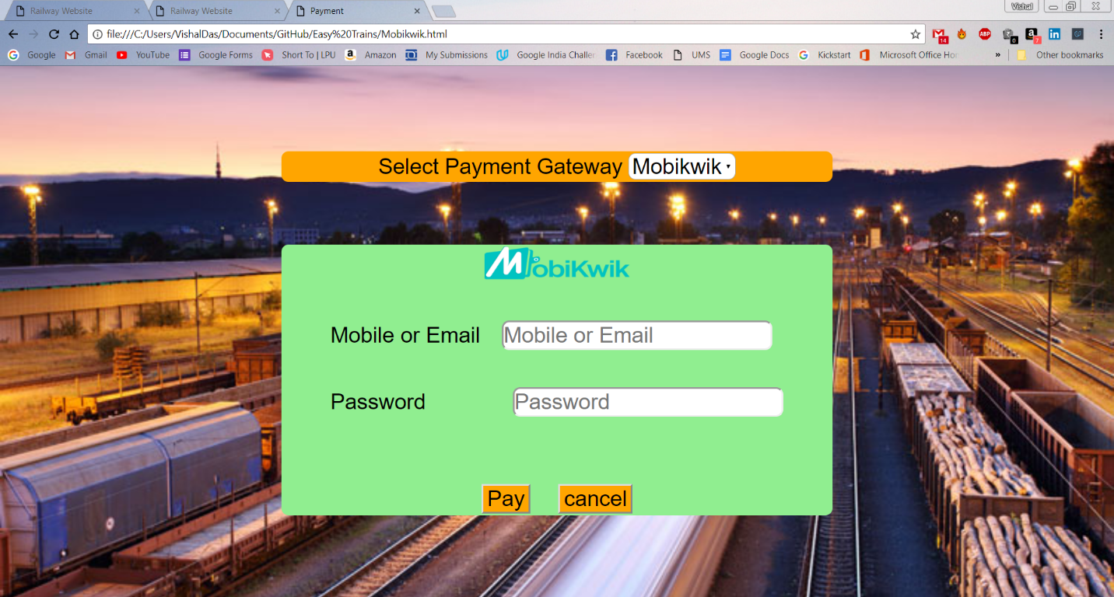

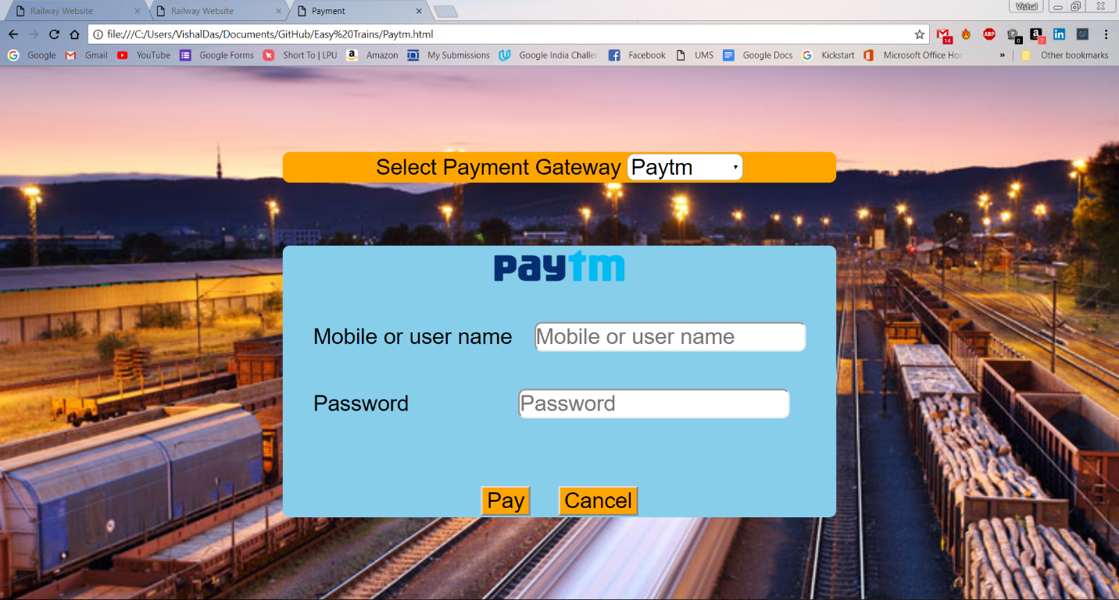

**Payment gateway**

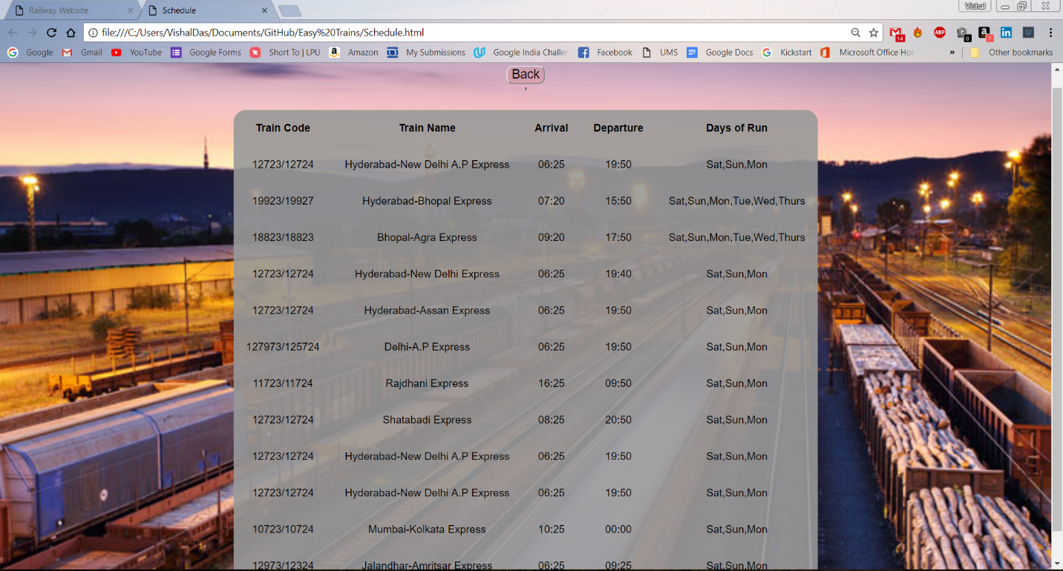**Schedule Page**

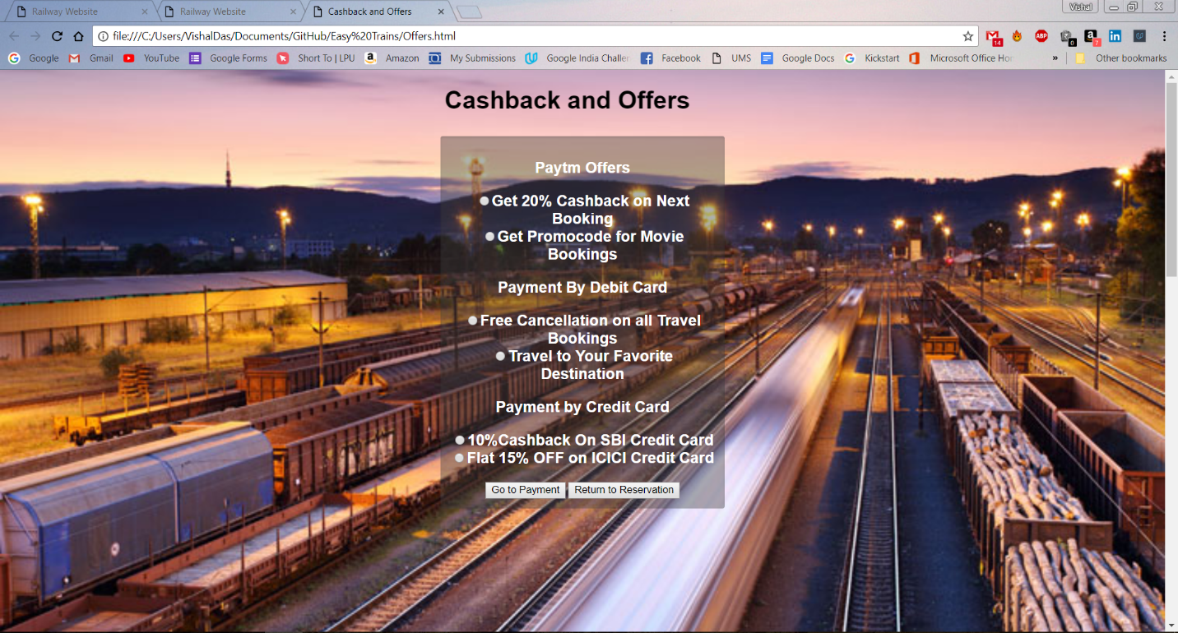

**Offers Page**

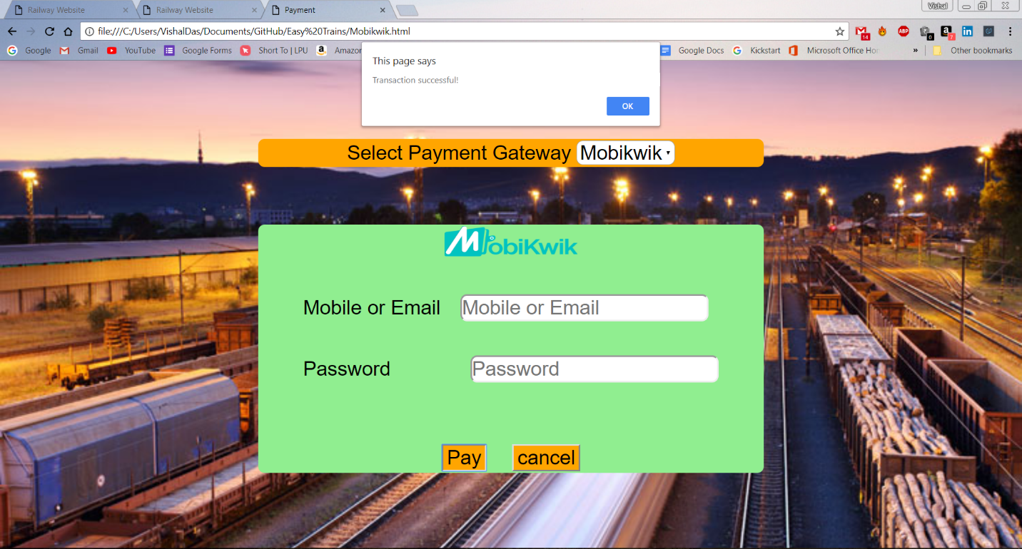

**Successful Transaction Notification**

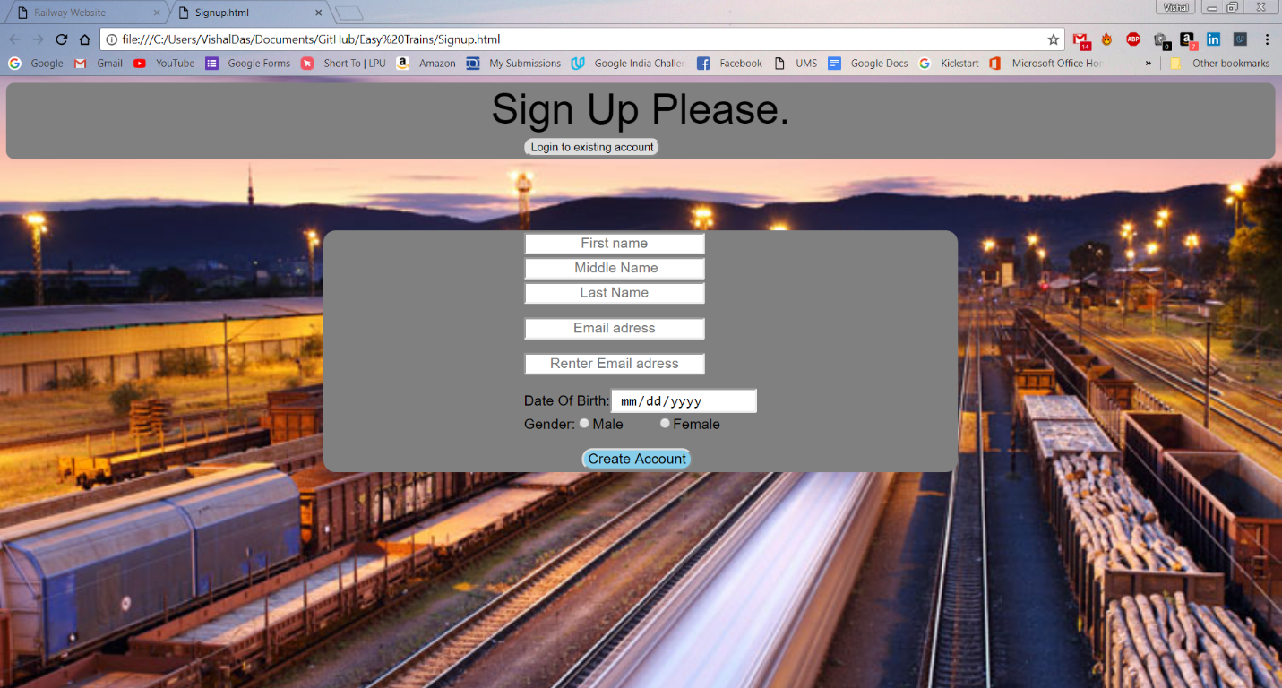

**Sign Up Page**

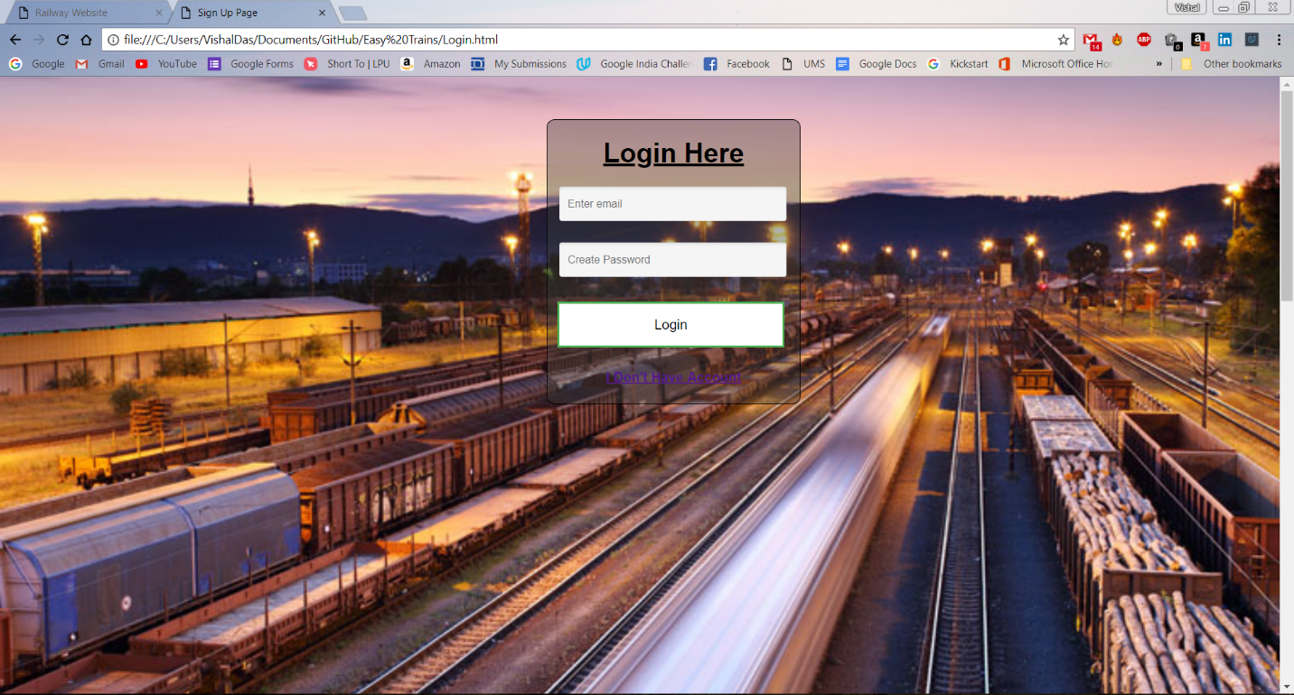

**Login Page**

**About our project and its capabilities**

1. We have designed our project in such a way it provides an easy way of booking a ticket and made travelling through train easier.

2. Our project gives accurate information of train schedule and secure mode of payment.

**LIMITATIONS:**

Our project meets the following limitations:

1. The fare allotted for every reservation is independent of Kilometers travelled instead it is set for every mode (AC, Non-AC or General) of each train.

2. The software does not provide concession in fare rates for children, aged people, and armament etc. i.e., the fare identical for all people.

3. The software does not take into consideration the stations falling in between the source and destination station.